# CPSC 2030 – Web Development II

**Lab9: [55 marks] Introduction to WordPress**

|  |
| --- |
| **Objectives** |
| * Install WordPress to your own computer * Try out some basic features of WordPress |
| **Preparation** |
| 1. Create a new folder named **Lab9** under your CPSC2030\Labs folder. 2. Download Lab9StarterFiles.zip from D2L and unzip it to the folder Lab9. |
| **What to do** |

The purpose of this lab assignment is to try out some of the basic features of WordPress. WordPress is a content management system that allows you to create a powerful, full-featured and highly customizable site without writing any code. (Although we will eventually write some code as we create our own WordPress themes!)

**Task 1: [5 marks] Setup**

Install WordPress according to the instructions given in the file

WordPress_Installation_Instructions_2022.docx (Download it from D2L).

You can also follow the instructions given on this site to do the installation:

https://wordpress.org/support/article/how-to-install-wordpress/

(**note**: name your wordpress subdirectory as **2030**)

Once you’ve completed installation and logged into your site, you’ll see a black menu bar at the top of your page:  
  
From here, you can access your **Dashboard**, where you can customize and configure all aspects of your site; just hover your mouse over the title of the site and choose **Dashboard** from the dropdown. When viewing the dashboard, you can click **Visit Site** to go to your site. You can come back to **Dashboard** by hovering your mouse over the title of the site and choose **Dashboard** from the dropdown.

Find a way to change the site title to **First Name’s Favorite Music** (with your own first name.) (hint: try looking in **Settings > General**) and the tagline to **The best music**

Go to **Appearance > Themes** to change the theme of your site to Twenty Twenty-One

Some basic content has been provided for you to import and use as a starter site:

* Go to **Tools > import > WordPress/ Install Now > Run Importer**. Choose the file **jordan039sfavoritemusic.WordPress.2019-03-04.xml** and import it. It will ask you to assign authors; just assign posts to an existing user (yourself.) There are no attachments to import.
* You now have one post (called "Janelle Monáe") added to your blog, in addition to the default “hello world” post. You should now see something like this at the top of your site:

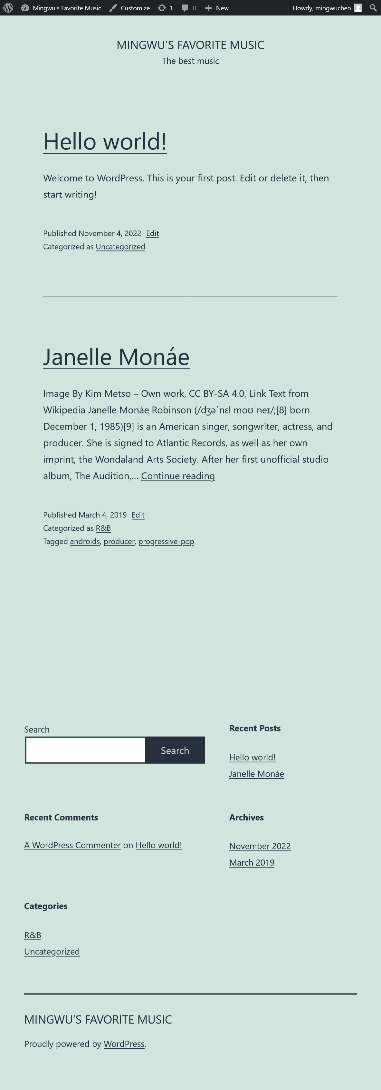

**Task 2: [15 marks] Editing and Creating Posts**

* In the Dashboard, find the **Posts** area. Find a way to delete the **Hello World** Post.
* Figure out how to open the **Janelle Monáe** post in the post editor. Spend a bit of time exploring the post editor to see how it works. This is where you create a new blog post with text, headings, images, and anything else you may want to put in a post.
* In the post editor, figure out how to add a **featured image**, which has been supplied for you in the **images** folder. (Hint: check the menu of options on the right side of the editor.) Make sure the image has some descriptive alt text. Note that a featured image is different from a regular post image. Don't forget to click the blue **Update** button in the top right corner to save your changes.



Now go back to the home page to see what your post looks like. You should see the featured image appear at the top of the page!

* Figure out how to add **a new post** about one of your favorite musical artists.   
    
  The WordPress Post editor uses a **block** system, in which posts are composed from various blocks for different kinds of content. You can add new blocks by clicking on the blue **+** button in the top left corner:  
    
    
    
  This will open a menu that allows you to choose which type of content you would like the new block to contain. The new block will be placed at the bottom of the post.   
    
  Try adding a new paragraph block. Once you've done this, you can click on it to edit it; try typing some text. You should also see a little mini toolbar appear above the block:   
    
    
    
  This toolbar gives you a few more options for styling and formatting the content. You can also click the **up and down** arrows to change the order of the block in the post (move it below or above other blocks.)  
    
  There's another, simpler way to add new blocks. If you hover on the space below or between existing blocks, a little blue plus icon will appear; you can click this to add a new block at that location:   
    
    
    
  Try adding a few different types of blocks to see how they work. Also, try rearranging them, and see if you can figure out how to delete a block. Once you feel comfortable with blocks, do the following:

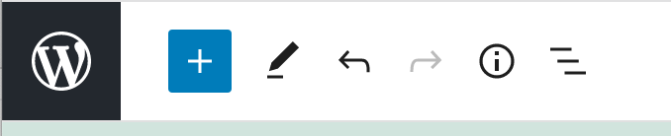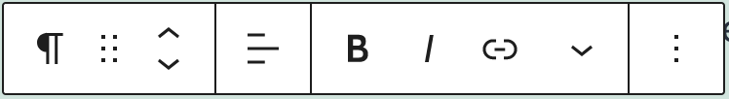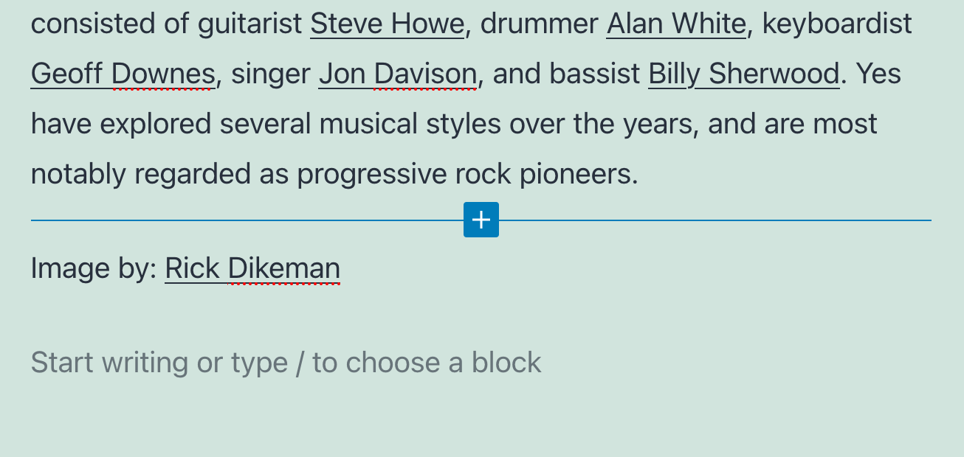

* + Add a heading with the name of one of your favorite music artists. (You don’t need to create a new block for this, you just type the name in the field at the top of the editor.)
  + Add a paragraph of text to the body of the post. Feel free to copy text from Wikipedia or some other free source.
  + Add another paragraph block to the top of the post with credit and a link to the source of the text you used. Figure out how to create a hyperlink.
  + Figure out how to add at least **three** **tags** to your post using the menu on the right. If you can't see this menu, you may have to reveal it using the **cog icon** in the top right corner:

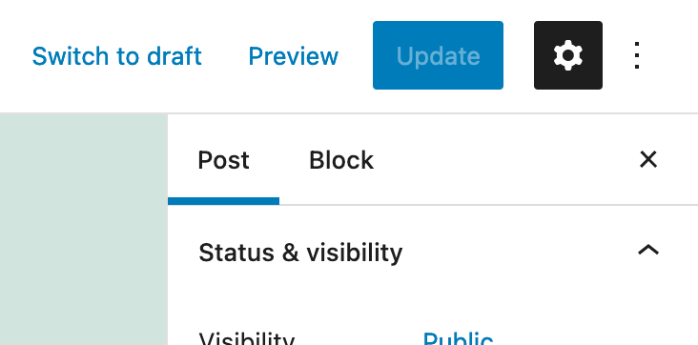

* + Also note that you may have to switch between the **Post** and **Block** tabs, which have options for editing the entire post and the currently-selected block, respectively.  
      
    You can use previously-used tags or create your own. Tags are a good way to allow users to find content on your site according to certain keywords that describe the post contents.
  + Add a **category** that represents the genre of the artist. Categories are a way of structuring the content of your site using a hierarchy. You can use a previously-used category or create your own. Remove the "Uncategorized" category from your post.

Add a **featured image**. Make sure the featured image has some descriptive **alt text.** (Get the image from Wikipedia or some other free source. Note that the image file size limit is 8 M by default.)   
  
Add a paragraph block at the top of the article with a link to the source of the image. Publish your post. When you view your new post, it should look something like this (see next page):

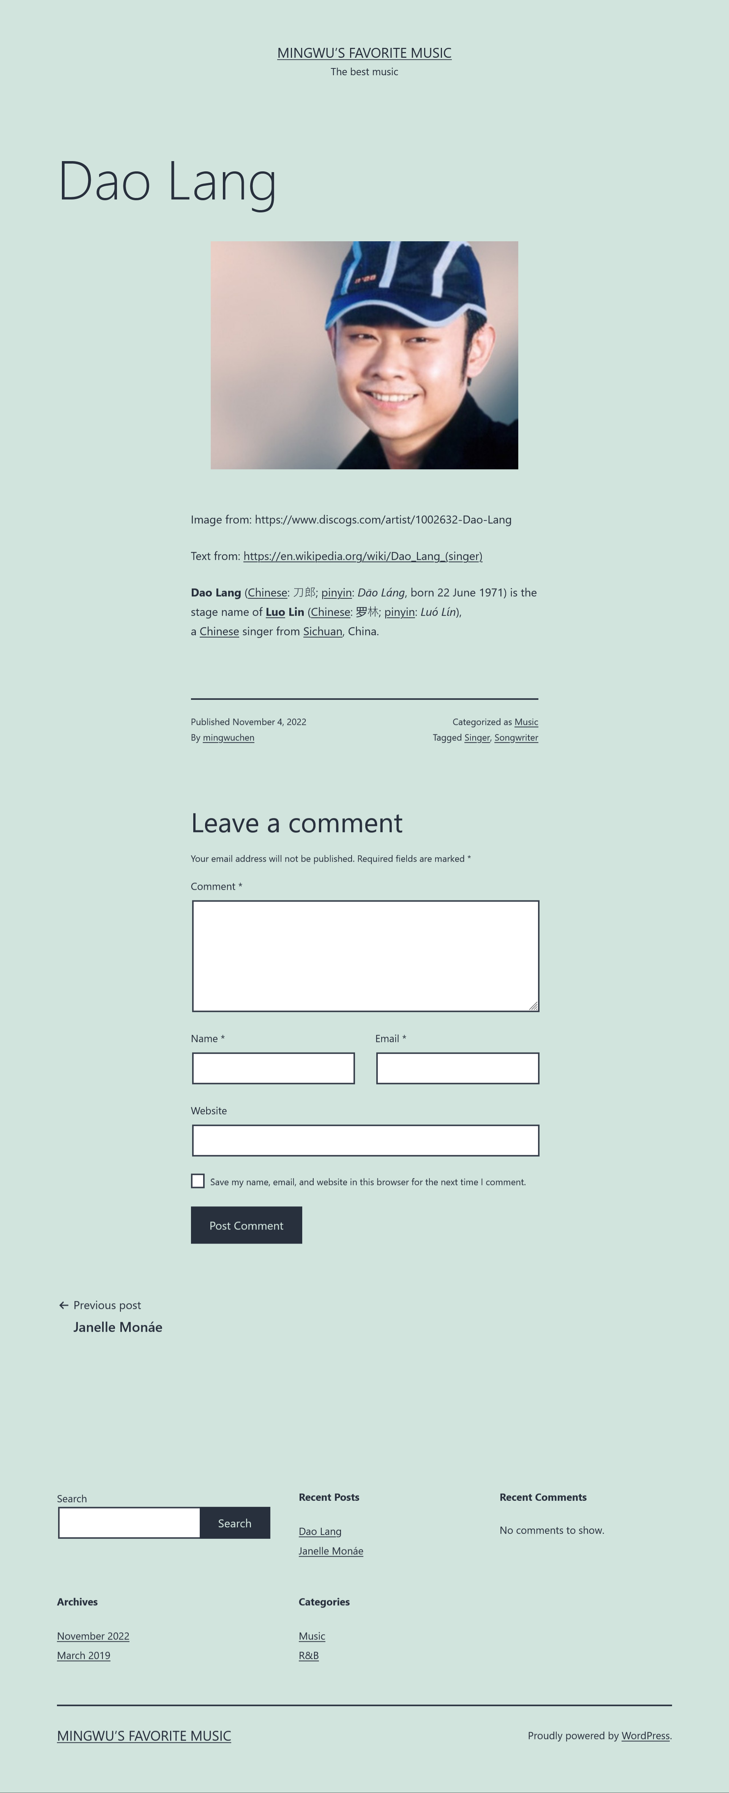

Create another post for another one of your favorite artists, with all the same features as the previous one, including its own tags and category.  
  
Notice that there are two different ways that posts appear on your site. The home page of the site has a list of all posts, with a small summary of the content for each one. When you click on the title of a post, you're taken to a special page just for that post, with the full content. Note also that each post will have an **Edit** link under it that you can use to quickly edit the post.

**Task 3: [10 marks] Creating Pages**

* Figure out how to create **a new Page** (*not* a post) called **“About”.** Write a brief description of the site. Add an **h3** heading (to do this, you can click on the **+** icon underneath the last block you edited) with the text **"About First Name"** and write one or two sentences about yourself. (You can just make something up if you want.) Add a **featured image** to this page. (It can be an image of anything, but do credit the source.)  
    
  What do you think the difference between a post and page is?  
    
  Once you've published the page, you will be able to view it through the dashboard, although it will not actually appear anywhere on the site.
* Delete the default **“Sample Page”** page. (You can keep the **Privacy Policy** page.)
* Your page should look something like this (next page):

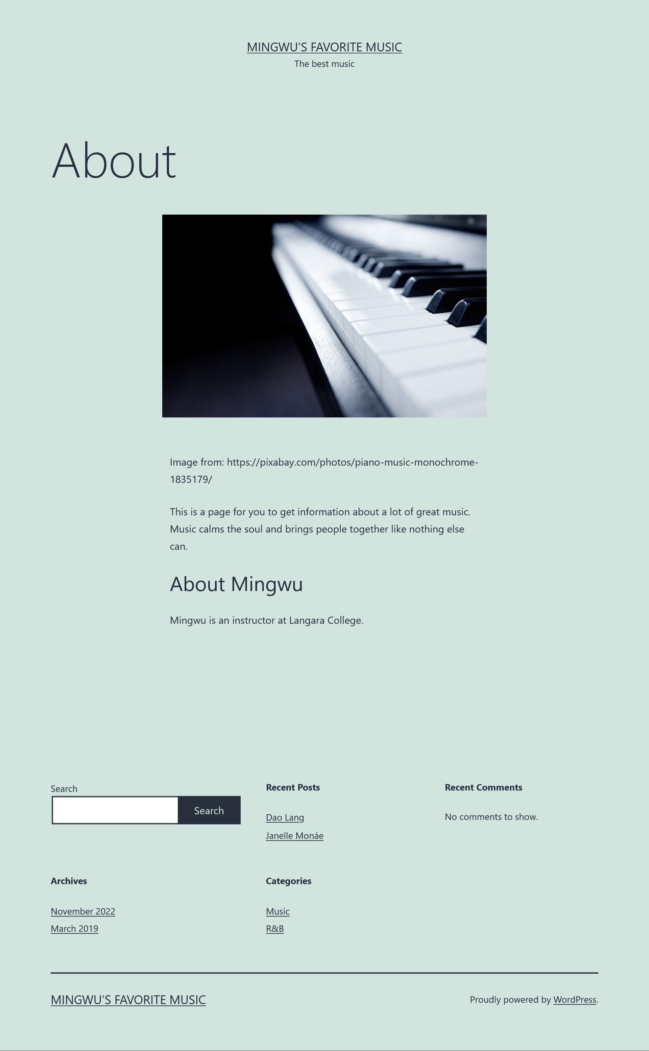

**Task 4: [5 marks] Navigation Menus**

You may have noticed that the new page we created actually doesn't show up anywhere on the site! Let's fix that:

* In the dashboard, go to **Appearance > Menus**. In the "Menu Name" input field, type ***main menu***. Set the **display location** to **"Primary menu"** and then click **Create Menu.**

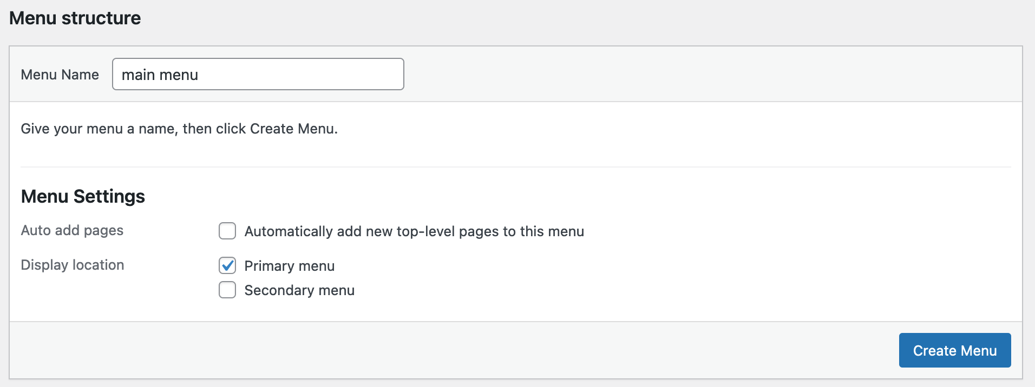

* Now figure out how to add your **About** page to the menu. Also add a link back to the home page. (hint: in the **Pages** area of the **Add menu items** menu, select the **View All** tab.) *Do not* simply make an absolute link to the home page using the URL in the address bar, since this URL will change when you migrate your site to a live server.   
    
  Save the menu and view your home page; you should be able to see the navigation links at the top of the page beside the site title and tagline:
* Now go back to the menu editor and add an item to your main menu for each **category** on your site.

Try out all the links in your menu to make sure they work.

**Task 5: [5 marks] URLs and Permalinks**

Visit one of the posts on your site and look at the URL for that post in the address bar. You might see that it consists of the date of the post, followed by a sanitized version of the name of the post, like this:  
  
**http://localhost/2030/wordpress/2022/11/4/dao-lang/**  
  
We can actually change the URL structure of our site by going to the **Dashboard, Settings > Permalinks.**

* Figure out a way to set up your URL structure so that when visiting a post the URL looks like this:

**http://localhost/2030/wordpress/categoryname/postname**  
**hint:** choose **"Custom Structure"** and choose the parameters you need from the list below. Then click **Save Changes.**  
  
Try visiting the Janelle Monáe post. The URL should now look something like this:

**http://localhost/2030/wordpress/rb/janelle-monae/**

**Task 6: [5 marks] Theme Customizations**

We are using a theme called **Twenty Twenty-One**, which defines the way the site looks and a few aspects of how it functions, such as where menus appear, style customizations, etc. WordPress has literally thousands of themes to choose from, and we will eventually create our own, but for now, let's just use **Twenty Twenty-One**. We can access the customizable features of the theme by going to any page in the browser (while logged in) and clicking **Customize** in the black admin bar at the top of the window.

This will open a side panel on the left with some customization options.

* Navigate to the **Colors & Dark Mode** panel and choose a new background color for your site. To save your changes, click the **Publish** button at the top of the customize panel.
* Now go to the **Additional CSS** panel. This allows you to actually write your own CSS code that will be attached to this instance of the theme.
  + Find a way to use this to change the **color** of the **tagline** and **h2 headings** of your site to something else, includingthe titles of posts on the home page. (hint: use the Inspect tool in your browser to figure out how to select these items in CSS.)
  + Set the font size of the main heading of the site to **4rem**.

**Task 7: [5 marks] Plugins**

One of the great things about WordPress is the large developer community that creates and maintains thousands of plugins; no matter which problem you may need to solve, you can bet someone has written a plugin for that. For this assignment, we'll use a plugin to easily create a contact form. (However, this form won't actually work unless we migrate our site to a live server.)

In the Dashboard, go to **Plugins > Add New**. Search for a plugin called **Contact Form 7** *By Takayuki Miyoshi*.

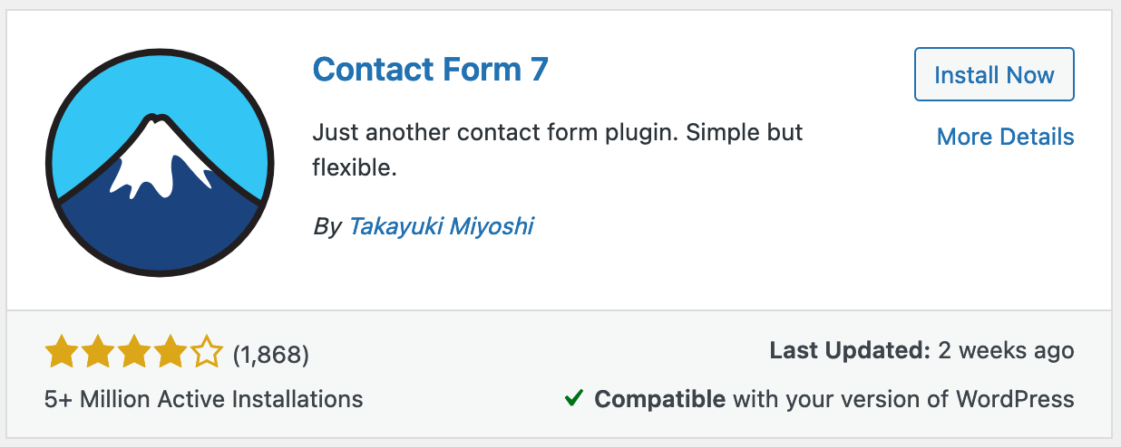

Figure out how to install and activate this plugin. Once installed, you should see a **Contact** option appear on your dashboard. Figure out how to make a basic contact form (you can use the default form or choose your own features) and add it to a new page called **Contact**. (There are a few different ways to add a contact form to page; see if you can figure out how.) Add this new page to your main menu.

**Task 8: [5 marks] Explore Themes**

Without much effort, we've been able to quickly add some content, define a rough structure for the site with a navigation menu, customize the look and feel, and extend the functionality with a plugin. For this last task, explore a few other themes to see how easy it is to transform the UI of the site and take advantage of the creativity of WordPress's large theme developer community. To do this, in the dashboard go to **Appearance > Themes > Add New.** Download and install a few themes. (Warning: for security reasons, It is not recommended to use a theme if it hasn’t been verified by WordPress and published through their theme explorer or through WordPress.org.)

Try out at least **one** new theme, and take a screenshot of your homepage using that theme. Rename the screenshot file to **alternate-theme** (with the appropriate file extension, depending on your screenshot software). Please switch back to **Twenty Twenty-One** before handing in your assignment.

|  |
| --- |
| **What to hand in** |
| Check the screenshots provided in the starter files to make sure your site looks roughly the same. Take a screenshot of the following pages:   * Home page * Single post page * About page * Contact page * Category page for one category   Name these files **home, post, about, contact** and **category**, respectively. Place these files in a folder named **Lab9Submission** along with the **alternate-theme** image file. Zip the folder **Lab9Submission** and hand it in to D2L. |
| **When to hand in** |
| * By 11:59pm, Sunday, November 13, 2022 |